Table S: NO2 concentration by state

|  |  |  |  |  |  |  |
| --- | --- | --- | --- | --- | --- | --- |
| **State** | **Mean** | **Min** | **25%** | **Median** | **75%** | **Max** |
| Alabama | 10.3 | 3.0 | 7.1 | 9.3 | 12.5 | 33.8 |
| Arizona | 17.0 | 4.6 | 10.1 | 15.1 | 23.4 | 45.9 |
| Arkansas | 9.3 | 3.2 | 6.2 | 8.1 | 11.6 | 28.0 |
| California | 21.1 | 1.6 | 12.7 | 19.3 | 27.9 | 58.3 |
| Colorado | 18.1 | 3.4 | 9.3 | 15.2 | 24.8 | 56.9 |
| Connecticut | 15.6 | 7.3 | 11.9 | 15.0 | 18.6 | 36.2 |
| Delaware | 13.2 | 7.1 | 9.3 | 11.6 | 16.7 | 28.7 |
| District Of Columbia | 26.3 | 20.2 | 24.2 | 25.4 | 28.5 | 36.1 |
| Florida | 10.7 | 1.8 | 7.4 | 10.2 | 13.7 | 29.2 |
| Georgia | 10.8 | 3.0 | 6.8 | 9.8 | 13.6 | 41.4 |
| Idaho | 9.8 | 3.1 | 6.4 | 8.8 | 12.6 | 26.9 |
| Illinois | 19.0 | 4.4 | 10.1 | 15.5 | 26.9 | 55.7 |
| Indiana | 15.4 | 6.7 | 10.7 | 14.4 | 18.7 | 38.9 |
| Iowa | 9.1 | 4.3 | 6.1 | 8.0 | 11.7 | 22.6 |
| Kansas | 9.7 | 4.5 | 6.3 | 8.8 | 12.4 | 28.7 |
| Kentucky | 12.4 | 6.1 | 8.9 | 10.8 | 14.8 | 33.3 |
| Louisiana | 9.6 | 3.0 | 5.3 | 8.0 | 12.6 | 31.4 |
| Maine | 6.3 | 2.0 | 4.4 | 5.8 | 7.5 | 18.7 |
| Maryland | 16.1 | 5.9 | 11.8 | 15.3 | 20.8 | 34.0 |
| Massachusetts | 14.1 | 3.7 | 10.3 | 13.2 | 17.0 | 42.5 |
| Michigan | 12.9 | 2.8 | 7.7 | 11.3 | 17.5 | 35.9 |
| Minnesota | 9.9 | 2.9 | 5.0 | 7.8 | 12.5 | 40.8 |
| Mississippi | 8.3 | 3.1 | 5.6 | 7.0 | 10.2 | 24.9 |
| Missouri | 9.3 | 4.4 | 6.8 | 8.4 | 11.0 | 23.8 |
| Montana | 6.2 | 1.7 | 4.0 | 5.5 | 8.0 | 14.8 |
| Nebraska | 8.6 | 3.0 | 5.2 | 7.7 | 11.1 | 26.5 |
| Nevada | 15.9 | 5.5 | 10.5 | 14.7 | 20.8 | 35.2 |
| New Hampshire | 9.1 | 5.0 | 7.4 | 8.4 | 10.3 | 20.2 |
| New Jersey | 21.0 | 7.1 | 15.8 | 20.2 | 25.7 | 48.1 |
| New Mexico | 12.1 | 4.7 | 7.9 | 11.0 | 14.8 | 35.0 |
| New York | 16.6 | 3.2 | 8.3 | 12.4 | 23.9 | 48.7 |
| North Carolina | 11.0 | 3.2 | 8.0 | 10.4 | 13.5 | 31.1 |
| North Dakota | 5.4 | 2.1 | 3.3 | 4.0 | 6.9 | 17.6 |
| Ohio | 14.3 | 7.5 | 10.7 | 13.6 | 17.3 | 35.2 |
| Oklahoma | 10.4 | 4.1 | 7.0 | 9.5 | 13.1 | 28.5 |
| Oregon | 11.1 | 1.5 | 7.0 | 10.1 | 14.3 | 31.0 |
| Pennsylvania | 16.6 | 6.4 | 12.2 | 15.5 | 20.1 | 43.7 |
| Rhode Island | 13.8 | 5.9 | 11.1 | 13.7 | 16.2 | 29.2 |
| South Carolina | 9.4 | 3.3 | 6.4 | 8.9 | 11.9 | 25.1 |
| South Dakota | 5.2 | 1.8 | 3.3 | 4.2 | 6.7 | 15.8 |
| Tennessee | 12.7 | 5.9 | 9.2 | 11.2 | 15.0 | 38.3 |
| Texas | 11.5 | 1.9 | 7.0 | 10.4 | 14.5 | 40.6 |
| Utah | 17.0 | 4.3 | 10.0 | 15.4 | 23.4 | 39.8 |
| Vermont | 8.3 | 3.3 | 7.1 | 7.9 | 9.1 | 18.7 |
| Virginia | 13.5 | 5.3 | 9.2 | 12.0 | 17.1 | 36.1 |
| Washington | 14.9 | 2.9 | 9.3 | 13.6 | 19.1 | 48.9 |
| West Virginia | 12.7 | 6.9 | 10.3 | 11.9 | 14.9 | 25.5 |
| Wisconsin | 10.6 | 2.8 | 6.6 | 9.3 | 13.5 | 35.7 |
| Wyoming | 7.6 | 2.0 | 4.5 | 6.7 | 10.1 | 21.4 |

Table S: Childhood asthma survey summary by state (Total of 2006-2010)

|  |  |  |  |  |  |  |
| --- | --- | --- | --- | --- | --- | --- |
| **State** | **BRFSS sample** | **Ever asthma** | **ACBS Sample** | **Incident case** | **At-risk** | **Years available** |
| Arizona | 5,535 | 699 | 103 | 10 | 4,846 |  |
| California | 11,801 | 1,543 | 172 | 13 | 10,271 |  |
| Connecticut | 7,112 | 1,132 | 549 | 47 | 6,027 |  |
| D.C. | 4,101 | 685 | 69 | 6 | 3,422 |  |
| Georgia | 9,433 | 1,455 | 545 | 26 | 8,004 |  |
| Illinois | 6,187 | 778 | 122 | 6 | 5,415 |  |
| Indiana | 9,824 | 1,361 | 500 | 41 | 8,504 |  |
| Iowa | 8,084 | 724 | 245 | 19 | 7,379 |  |
| Kansas | 14,699 | 1,839 | 827 | 50 | 12,910 |  |
| Louisiana | 8,829 | 1,214 | 88 | 4 | 7,619 |  |
| Maine | 4,523 | 644 | 376 | 23 | 3,902 |  |
| Maryland | 13,093 | 1,897 | 624 | 44 | 11,240 |  |
| Michigan | 10,762 | 1,524 | 680 | 43 | 9,281 |  |
| Mississippi | 10,816 | 1,527 | 208 | 14 | 9,303 |  |
| Missouri | 5,646 | 814 | 262 | 20 | 4,852 |  |
| Montana | 8,609 | 909 | 286 | 17 | 7,717 |  |
| Nebraska | 17,883 | 1,644 | 717 | 53 | 16,292 |  |
| New Hampshire | 5,285 | 664 | 232 | 19 | 4,640 |  |
| New Jersey | 15,410 | 2,230 | 458 | 32 | 13,212 |  |
| New Mexico | 5,554 | 765 | 287 | 17 | 4,806 |  |
| New York | 7,083 | 1,079 | 404 | 28 | 6,032 |  |
| Ohio | 7,989 | 1,138 | 351 | 32 | 6,883 |  |
| Oklahoma | 8,611 | 1,291 | 299 | 21 | 7,341 |  |
| Oregon | 4,793 | 579 | 165 | 13 | 4,227 |  |
| Pennsylvania | 14,760 | 2,090 | 209 | 12 | 12,682 |  |
| Rhode Island | 7,127 | 1,209 | 169 | 11 | 5,929 |  |
| Texas | 16,749 | 2,293 | 780 | 55 | 14,511 |  |
| Utah | 14,417 | 1,617 | 573 | 45 | 12,845 |  |
| Vermont | 8,784 | 1,220 | 597 | 40 | 7,604 |  |
| Washington | 9,706 | 1,165 | 594 | 33 | 8,574 |  |
| West Virginia | 5,089 | 663 | 85 | 5 | 4,431 |  |
| Wisconsin | 5,170 | 611 | 140 | 10 | 4,569 |  |

Table S: Childhood asthma survey weighted summary by state (Total of 2006-2010)

|  |  |  |  |  |  |  |
| --- | --- | --- | --- | --- | --- | --- |
| **State** | **Weighted sample** | **Ever asthma** | **Incident case** | **At-risk** | **Incidence rate** | **Prevalence rate** |
| Arizona | 6,631,643 | 866,487 | 42,622 | 2,802,422 | 15.2 | 13.1 |
| California | 36,944,762 | 4,513,981 | 156,599 | 16,850,453 | 9.3 | 12.2 |
| Connecticut | 3,216,911 | 515,372 | 32,939 | 2,734,478 | 12.0 | 16.0 |
| D.C. | 550,985 | 109,403 | 3,184 | 179,493 | 17.7 | 19.9 |
| Georgia | 12,211,232 | 1,847,944 | 94,786 | 10,458,074 | 9.1 | 15.1 |
| Illinois | 12,758,371 | 1,580,896 | 37,799 | 5,673,571 | 6.7 | 12.4 |
| Indiana | 7,837,910 | 1,006,366 | 105,219 | 6,936,762 | 15.2 | 12.8 |
| Iowa | 3,410,014 | 287,609 | 11,510 | 1,829,734 | 6.3 | 8.4 |
| Kansas | 3,428,398 | 396,147 | 27,509 | 3,059,760 | 9.0 | 11.6 |
| Louisiana | 2,178,496 | 282,443 | 5,379 | 931,966 | 5.8 | 13.0 |
| Maine | 825,221 | 109,120 | 6,662 | 722,763 | 9.2 | 13.2 |
| Maryland | 6,754,689 | 1,002,976 | 64,871 | 5,816,584 | 11.2 | 14.8 |
| Michigan | 11,990,510 | 1,625,547 | 126,102 | 10,491,065 | 12.0 | 13.6 |
| Mississippi | 3,630,503 | 515,551 | 18,264 | 1,300,917 | 14.0 | 14.2 |
| Missouri | 5,518,464 | 766,864 | 46,410 | 3,600,272 | 12.9 | 13.9 |
| Montana | 1,059,004 | 102,944 | 3,296 | 768,012 | 4.3 | 9.7 |
| Nebraska | 2,201,248 | 204,905 | 18,262 | 2,014,605 | 9.1 | 9.3 |
| New Hampshire | 886,427 | 107,549 | 9,423 | 788,302 | 12.0 | 12.1 |
| New Jersey | 8,196,056 | 1,168,380 | 51,472 | 5,274,310 | 9.8 | 14.3 |
| New Mexico | 1,497,760 | 179,121 | 8,857 | 1,327,496 | 6.7 | 12.0 |
| New York | 17,587,681 | 2,781,426 | 221,226 | 15,027,481 | 14.7 | 15.8 |
| Ohio | 8,133,870 | 997,198 | 71,568 | 4,755,245 | 15.1 | 12.3 |
| Oklahoma | 3,491,913 | 487,287 | 24,628 | 2,285,659 | 10.8 | 14.0 |
| Oregon | 2,525,767 | 281,481 | 8,328 | 752,768 | 11.1 | 11.1 |
| Pennsylvania | 13,667,687 | 1,905,109 | 62,292 | 4,733,925 | 13.2 | 13.9 |
| Rhode Island | 907,043 | 145,915 | 5,476 | 384,117 | 14.3 | 16.1 |
| Texas | 26,030,068 | 3,420,044 | 381,999 | 22,992,023 | 16.6 | 13.1 |
| Utah | 3,963,227 | 404,738 | 30,221 | 2,902,955 | 10.4 | 10.2 |
| Vermont | 646,239 | 89,457 | 6,498 | 563,280 | 11.5 | 13.8 |
| Washington | 3,063,863 | 330,138 | 18,647 | 2,752,373 | 6.8 | 10.8 |
| West Virginia | 1,877,224 | 238,133 | 3,847 | 325,031 | 11.8 | 12.7 |
| Wisconsin | 3,890,403 | 410,615 | 14,404 | 1,174,447 | 12.3 | 10.6 |

Table S: State results

|  |  |  |  |  |
| --- | --- | --- | --- | --- |
| **State** | **Total children** | **Asthma**  **Incident cases** | **Attributable**  **cases** | **Attributable**  **fraction** |
| **Alabama** | 1,132,459 | 11,700 | 1,380 | 11.8 |
| **Arizona** | 1,629,014 | 21,500 | 4,620 | 21.5 |
| **Arkansas** | 711,475 | 7,500 | 860 | 11.6 |
| **California** | 9,295,040 | 75,800 | 19,200 | 25.3 |
| **Colorado** | 1,225,609 | 12,900 | 3,010 | 23.4 |
| **Connecticut** | 817,015 | 8,300 | 1,500 | 18.2 |
| **Delaware** | 205,765 | 2,000 | 330 | 16 |
| **District Of Columbia** | 100,815 | 1,400 | 390 | 26.9 |
| **Florida** | 4,002,091 | 42,100 | 5,360 | 12.7 |
| **Georgia** | 2,491,552 | 19,200 | 2,770 | 14.5 |
| **Idaho** | 429,072 | 4,700 | 590 | 12.6 |
| **Illinois** | 3,129,179 | 18,300 | 4,510 | 24.7 |
| **Indiana** | 1,608,298 | 21,300 | 3,850 | 18.1 |
| **Iowa** | 727,993 | 4,200 | 520 | 12.4 |
| **Kansas** | 726,939 | 5,800 | 790 | 13.6 |
| **Kentucky** | 1,023,371 | 10,700 | 1,590 | 14.9 |
| **Louisiana** | 1,118,015 | 5,600 | 650 | 11.6 |
| **Maine** | 274,533 | 2,200 | 170 | 7.9 |
| **Maryland** | 1,352,964 | 12,800 | 2,450 | 19.1 |
| **Massachusetts** | 1,418,923 | 14,900 | 2,470 | 16.6 |
| **Michigan** | 2,344,068 | 24,400 | 4,060 | 16.7 |
| **Minnesota** | 1,284,063 | 14,100 | 2,120 | 15.1 |
| **Mississippi** | 755,555 | 9,100 | 930 | 10.2 |
| **Missouri** | 1,425,436 | 15,800 | 1,900 | 12 |
| **Montana** | 223,563 | 900 | 70 | 8 |
| **Nebraska** | 459,221 | 3,800 | 490 | 13.1 |
| **Nevada** | 665,008 | 7,200 | 1,430 | 19.9 |
| **New Hampshire** | 287,234 | 3,000 | 330 | 10.9 |
| **New Jersey** | 2,065,214 | 17,300 | 4,160 | 24 |
| **New Mexico** | 518,672 | 3,000 | 470 | 15.4 |
| **New York** | 4,324,929 | 53,600 | 13,500 | 25.2 |
| **North Carolina** | 2,281,635 | 24,000 | 3,100 | 12.9 |
| **North Dakota** | 149,871 | 1,700 | 140 | 8.6 |
| **Ohio** | 2,730,751 | 36,100 | 6,160 | 17.1 |
| **Oklahoma** | 929,666 | 8,600 | 1,150 | 13.4 |
| **Oregon** | 866,453 | 8,500 | 1,180 | 13.9 |
| **Pennsylvania** | 2,792,155 | 31,600 | 6,310 | 20 |
| **Rhode Island** | 223,956 | 2,700 | 420 | 15.7 |
| **South Carolina** | 1,080,474 | 11,400 | 1,250 | 11 |
| **South Dakota** | 202,797 | 2,100 | 160 | 7.6 |
| **Tennessee** | 1,496,001 | 15,700 | 2,440 | 15.5 |
| **Texas** | 6,865,824 | 99,100 | 14,320 | 14.4 |
| **Utah** | 871,027 | 8,100 | 1,670 | 20.5 |
| **Vermont** | 129,233 | 1,300 | 130 | 9.8 |
| **Virginia** | 1,853,677 | 19,400 | 3,320 | 17.2 |
| **Washington** | 1,581,354 | 9,600 | 1,700 | 17.8 |
| **West Virginia** | 387,418 | 4,000 | 580 | 14.4 |
| **Wisconsin** | 1,339,492 | 14,700 | 2,150 | 14.7 |
| **Wyoming** | 135,402 | 1,500 | 140 | 9.7 |

Table S5: Comparing results by state

|  |  |  |  |  |  |  |  |  |
| --- | --- | --- | --- | --- | --- | --- | --- | --- |
| **State** | **State cases** | **Origin cases** | **Diff** | **% Diff** | **State AC** | **Origin AC** | **Diff** | **% Diff** |
| Montana | 866 | 2,412 | -1,546 | -64.1% | 69 | 192 | -123 | -64.1% |
| Louisiana | 5,616 | 12,061 | -6,445 | -53.4% | 653 | 1,401 | -749 | -53.4% |
| Iowa | 4,193 | 7,853 | -3,660 | -46.6% | 519 | 971 | -453 | -46.6% |
| Illinois | 18,264 | 33,756 | -15,492 | -45.9% | 4,509 | 8,333 | -3,824 | -45.9% |
| New Mexico | 3,047 | 5,595 | -2,548 | -45.5% | 471 | 864 | -394 | -45.5% |
| Washington | 9,559 | 17,059 | -7,500 | -44.0% | 1,703 | 3,039 | -1,336 | -44.0% |
| Georgia | 19,165 | 26,878 | -7,713 | -28.7% | 2,772 | 3,887 | -1,115 | -28.7% |
| Kansas | 5,781 | 7,842 | -2,061 | -26.3% | 787 | 1,067 | -281 | -26.3% |
| Maine | 2,196 | 2,962 | -766 | -25.9% | 173 | 234 | -60 | -25.9% |
| California | 75,829 | 100,270 | -24,442 | -24.4% | 19,205 | 25,395 | -6,190 | -24.4% |
| Nebraska | 3,775 | 4,954 | -1,179 | -23.8% | 494 | 648 | -154 | -23.8% |
| New Jersey | 17,281 | 22,278 | -4,997 | -22.4% | 4,155 | 5,357 | -1,202 | -22.4% |
| Oklahoma | 8,619 | 10,029 | -1,410 | -14.1% | 1,154 | 1,342 | -189 | -14.1% |
| Utah | 8,142 | 9,396 | -1,254 | -13.3% | 1,672 | 1,929 | -258 | -13.3% |
| Maryland | 12,849 | 14,595 | -1,746 | -12.0% | 2,454 | 2,787 | -333 | -12.0% |
| Oregon | 8,517 | 9,347 | -829 | -8.9% | 1,180 | 1,295 | -115 | -8.9% |
| Delaware | 2,036 | 2,220 | -184 | -8.3% | 326 | 355 | -29 | -8.3% |
| Vermont | 1,285 | 1,394 | -110 | -7.9% | 126 | 136 | -11 | -7.9% |
| Connecticut | 8,265 | 8,814 | -549 | -6.2% | 1,502 | 1,601 | -100 | -6.2% |
| West Virginia | 4,003 | 4,179 | -176 | -4.2% | 578 | 603 | -25 | -4.2% |
| Alabama | 11,722 | 12,216 | -494 | -4.0% | 1,381 | 1,439 | -58 | -4.0% |
| Michigan | 24,356 | 25,287 | -931 | -3.7% | 4,056 | 4,211 | -155 | -3.7% |
| Kentucky | 10,650 | 11,040 | -389 | -3.5% | 1,591 | 1,649 | -58 | -3.5% |
| Virginia | 19,375 | 19,997 | -622 | -3.1% | 3,323 | 3,430 | -107 | -3.1% |
| New Hampshire | 3,017 | 3,099 | -82 | -2.6% | 329 | 338 | -9 | -2.6% |
| Arkansas | 7,476 | 7,675 | -199 | -2.6% | 864 | 887 | -23 | -2.6% |
| Massachusetts | 14,910 | 15,307 | -396 | -2.6% | 2,473 | 2,539 | -66 | -2.6% |
| South Carolina | 11,354 | 11,656 | -302 | -2.6% | 1,254 | 1,287 | -33 | -2.6% |
| Tennessee | 15,720 | 16,138 | -418 | -2.6% | 2,438 | 2,503 | -65 | -2.6% |
| South Dakota | 2,131 | 2,188 | -57 | -2.6% | 161 | 165 | -4 | -2.6% |
| Colorado | 12,879 | 13,221 | -342 | -2.6% | 3,009 | 3,089 | -80 | -2.6% |
| North Carolina | 23,976 | 24,613 | -637 | -2.6% | 3,099 | 3,182 | -82 | -2.6% |
| Florida | 42,055 | 43,173 | -1,118 | -2.6% | 5,360 | 5,502 | -142 | -2.6% |
| Nevada | 7,170 | 7,174 | -4 | -0.1% | 1,430 | 1,431 | -1 | -0.1% |
| Wyoming | 1,482 | 1,461 | 22 | 1.5% | 144 | 141 | 2 | 1.5% |
| Minnesota | 14,061 | 13,852 | 210 | 1.5% | 2,124 | 2,093 | 32 | 1.5% |
| Wisconsin | 14,694 | 14,450 | 244 | 1.7% | 2,154 | 2,118 | 36 | 1.7% |
| Idaho | 4,724 | 4,629 | 96 | 2.1% | 593 | 581 | 12 | 2.1% |
| North Dakota | 1,652 | 1,617 | 36 | 2.2% | 142 | 139 | 3 | 2.2% |
| Missouri | 15,821 | 15,377 | 445 | 2.9% | 1,898 | 1,845 | 53 | 2.9% |
| Pennsylvania | 31,619 | 30,120 | 1,499 | 5.0% | 6,310 | 6,011 | 299 | 5.0% |
| Rhode Island | 2,679 | 2,416 | 263 | 10.9% | 422 | 380 | 41 | 10.9% |
| Mississippi | 9,101 | 8,151 | 951 | 11.7% | 929 | 832 | 97 | 11.7% |
| New York | 53,600 | 46,655 | 6,945 | 14.9% | 13,504 | 11,754 | 1,750 | 14.9% |
| Ohio | 36,060 | 29,458 | 6,602 | 22.4% | 6,165 | 5,036 | 1,129 | 22.4% |
| Indiana | 21,263 | 17,350 | 3,913 | 22.6% | 3,852 | 3,143 | 709 | 22.6% |
| Arizona | 21,538 | 17,573 | 3,965 | 22.6% | 4,623 | 3,772 | 851 | 22.6% |
| D.C. | 1,433 | 1,088 | 346 | 31.8% | 386 | 293 | 93 | 31.8% |
| Texas | 99,084 | 74,065 | 25,019 | 33.8% | 14,316 | 10,701 | 3,615 | 33.8% |

Figure S1: NO2 concentration (ug/m3) by living location

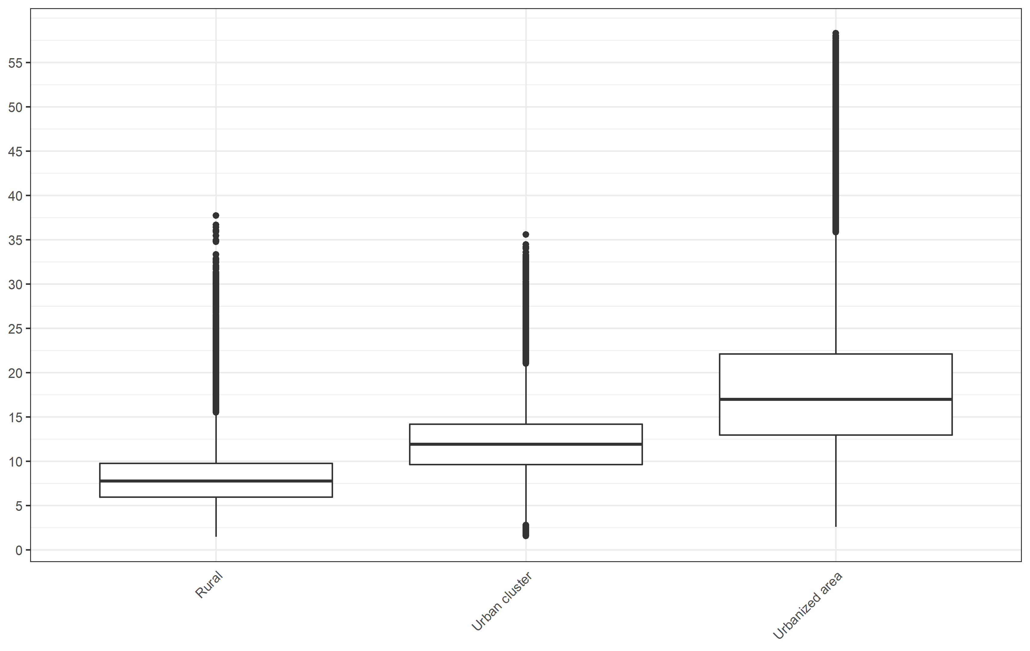

Figure S2: NO2 concentration (ug/m3) by median income group

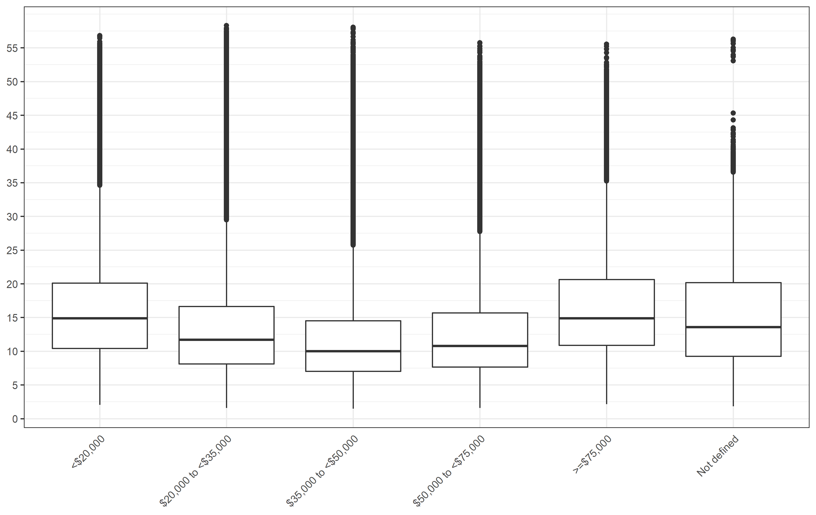

Figure S3: NO2 concentration (ug/m3) by living location stratified into median income group

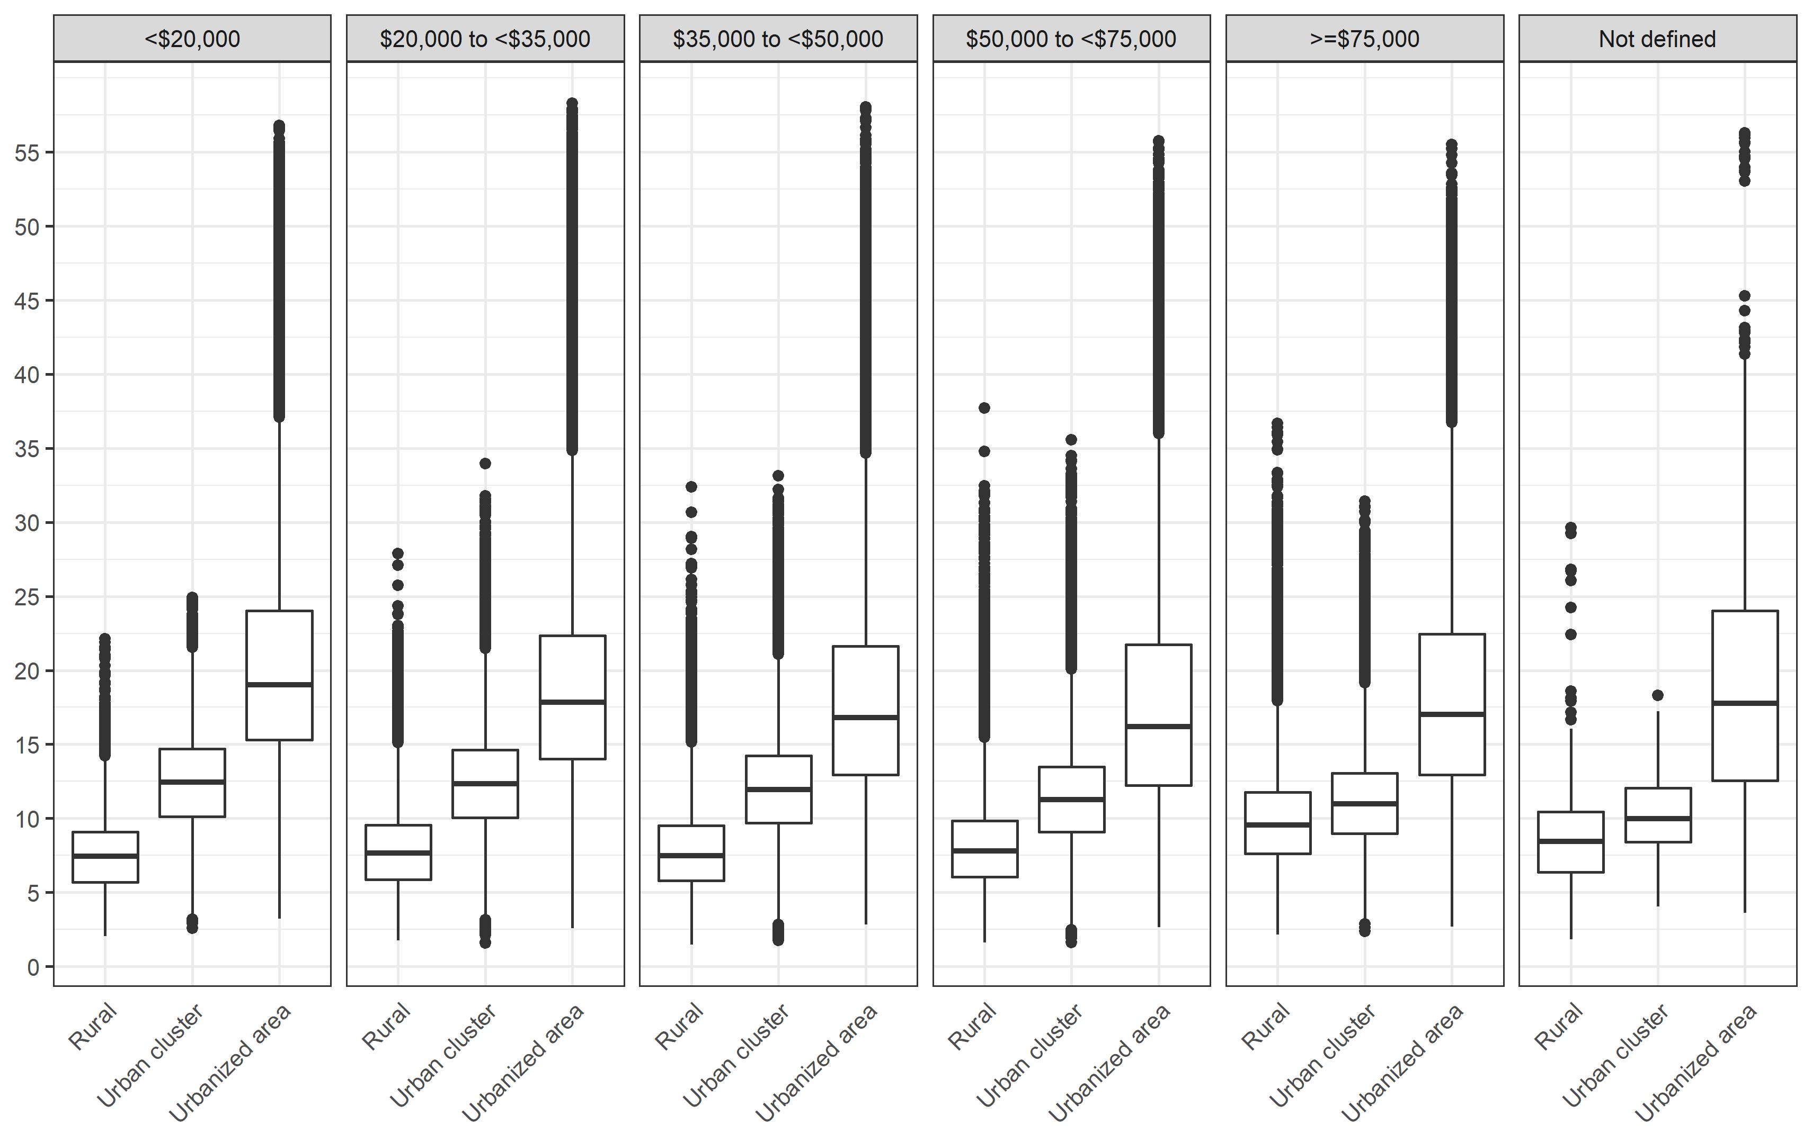

Figure S4: NO2 concentration (ug/m3) by median income group stratified into living location

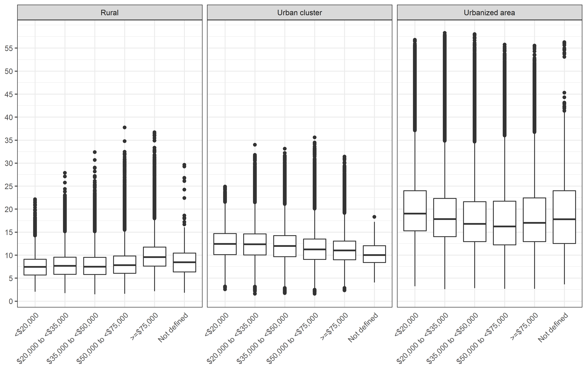

Figure S5: NO2 concentration (ug/m3) by state

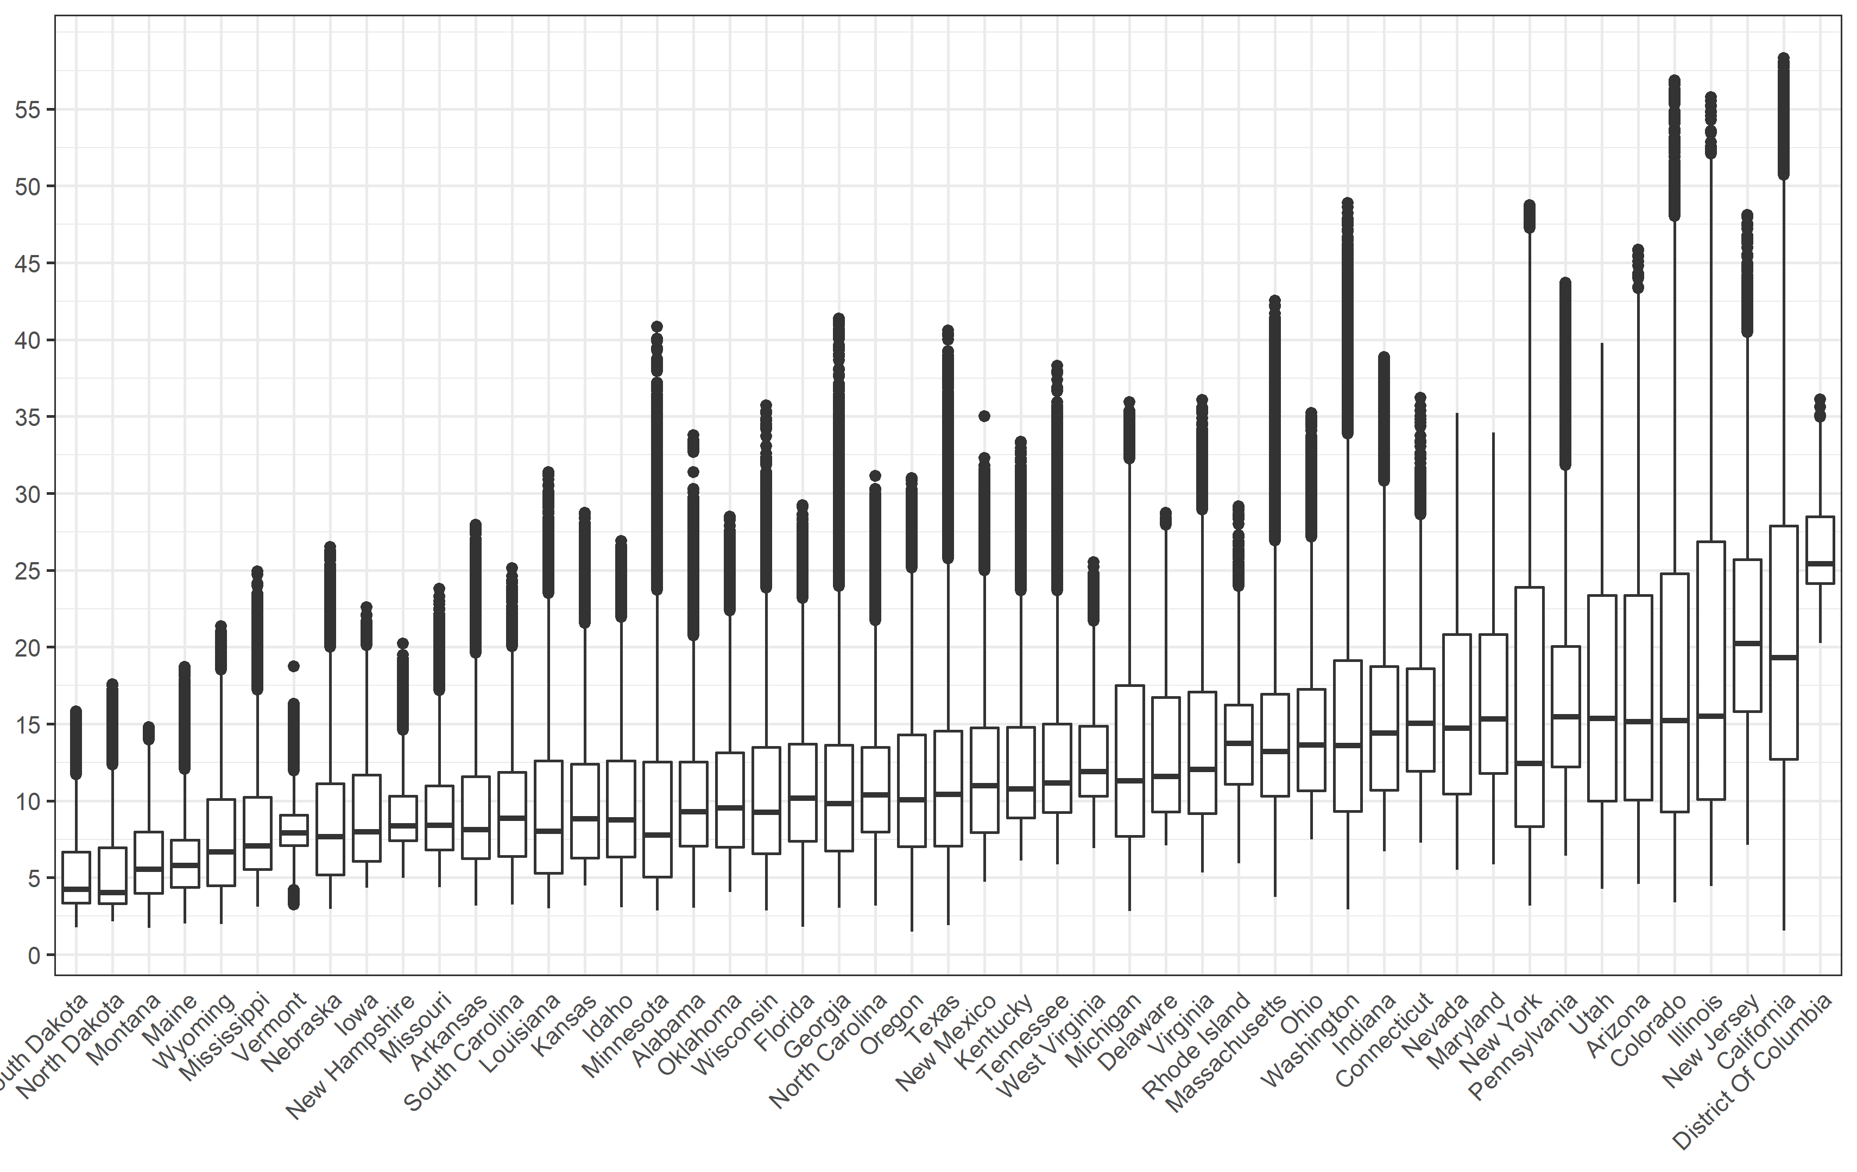

Figure S6: NO2 concentration (ug/m3) by state and median income group

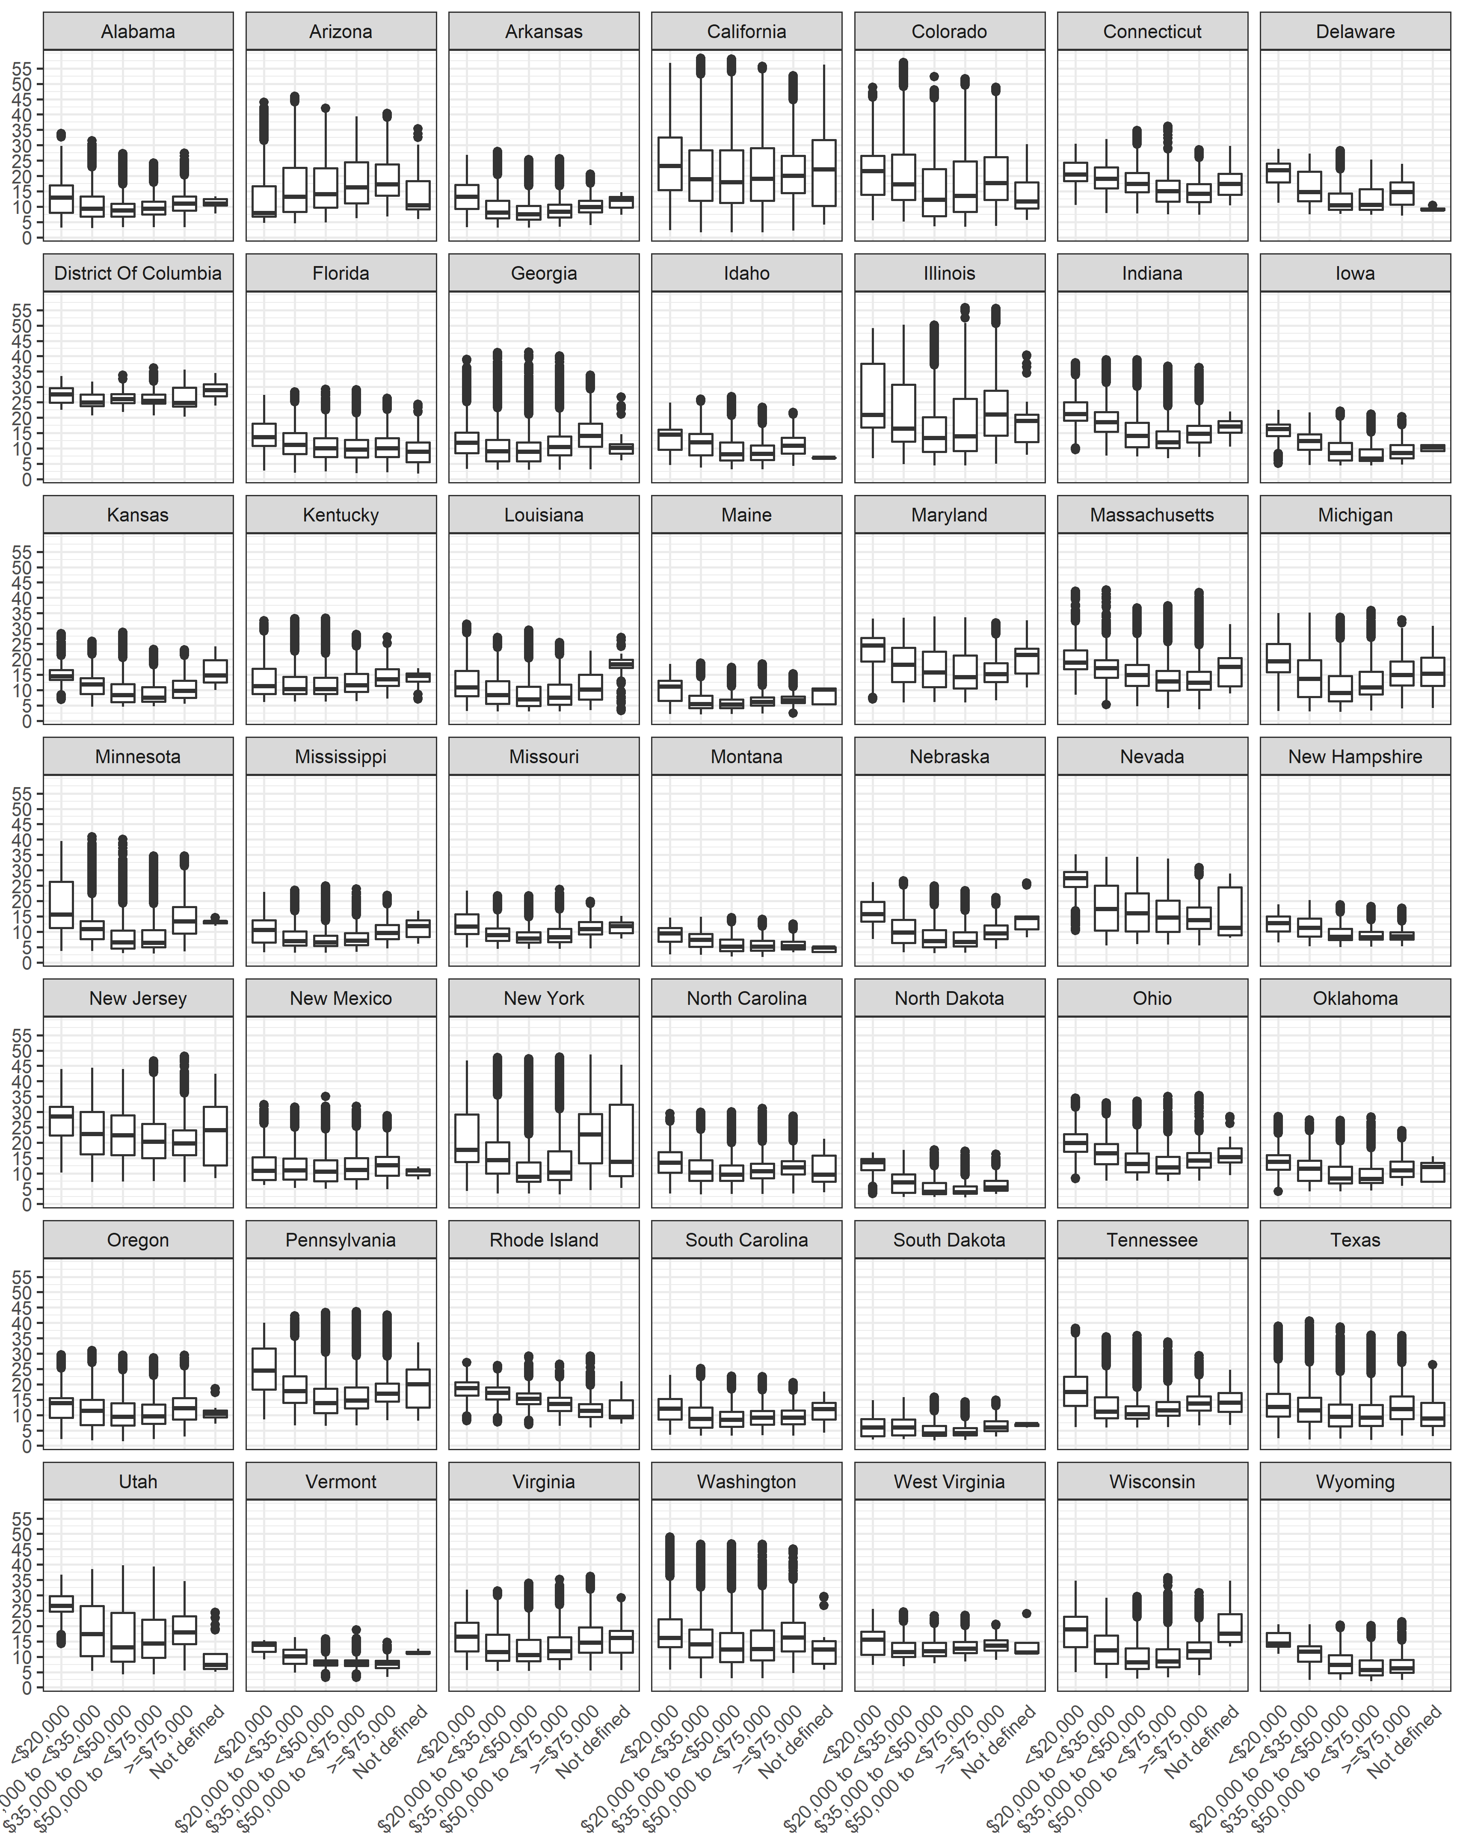

Figure S7: NO2 concentration (ug/m3) by state and living location

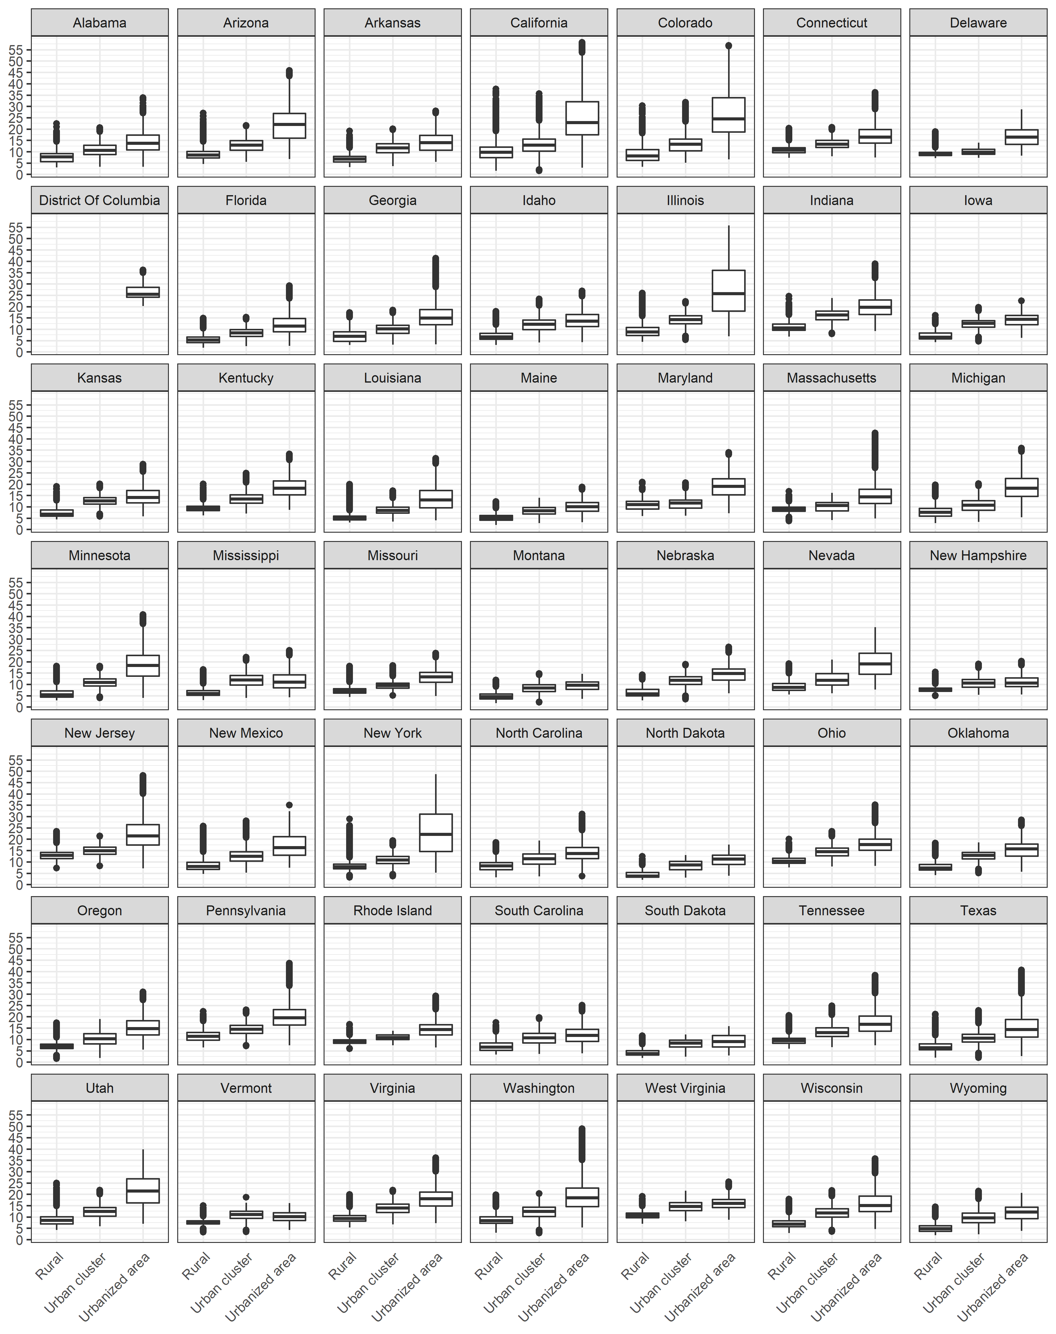

Figure S8: Attributable Fraction by living location

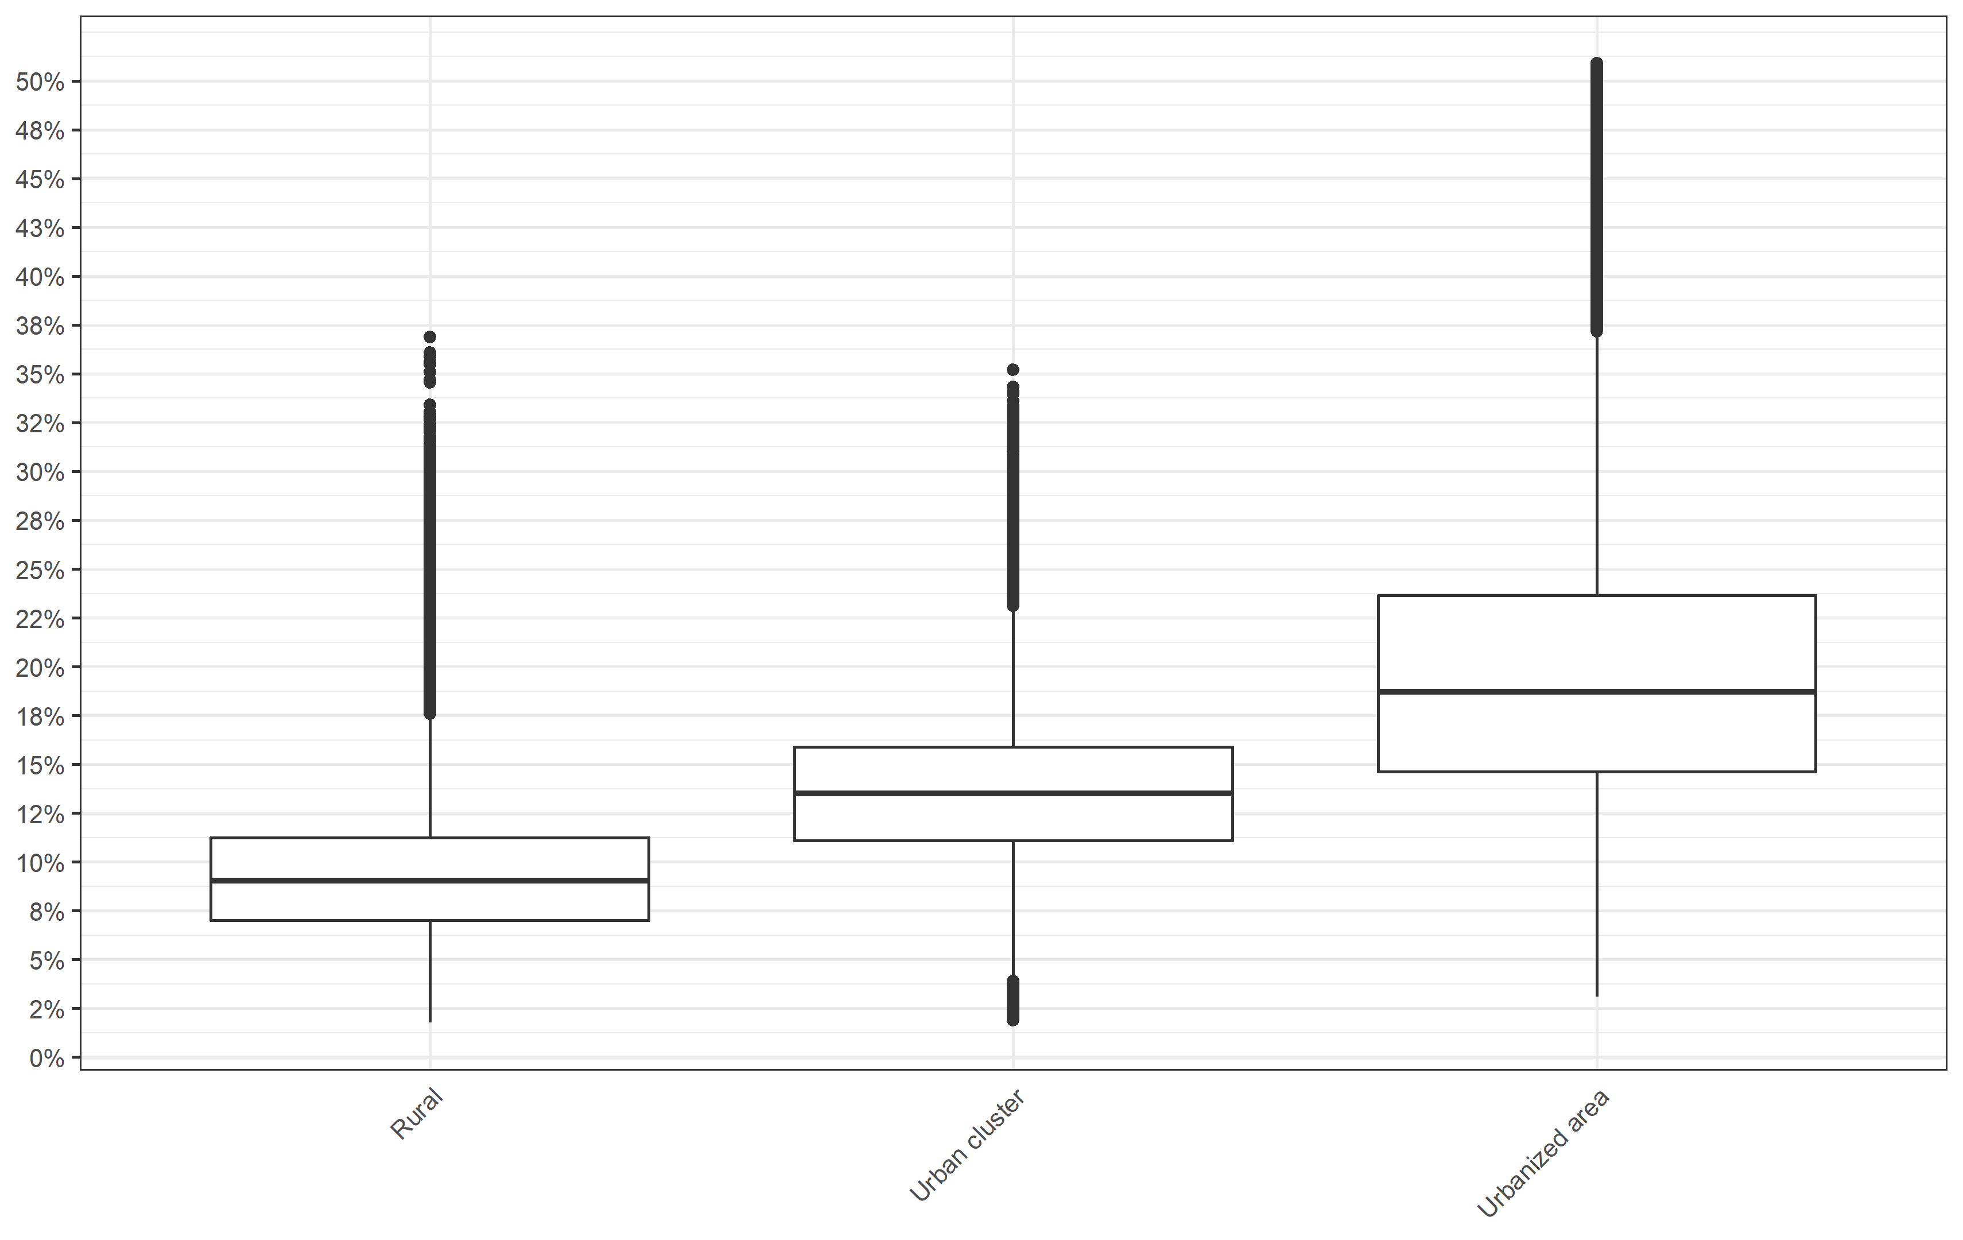

Figure S9: Attributable Fraction by median income group

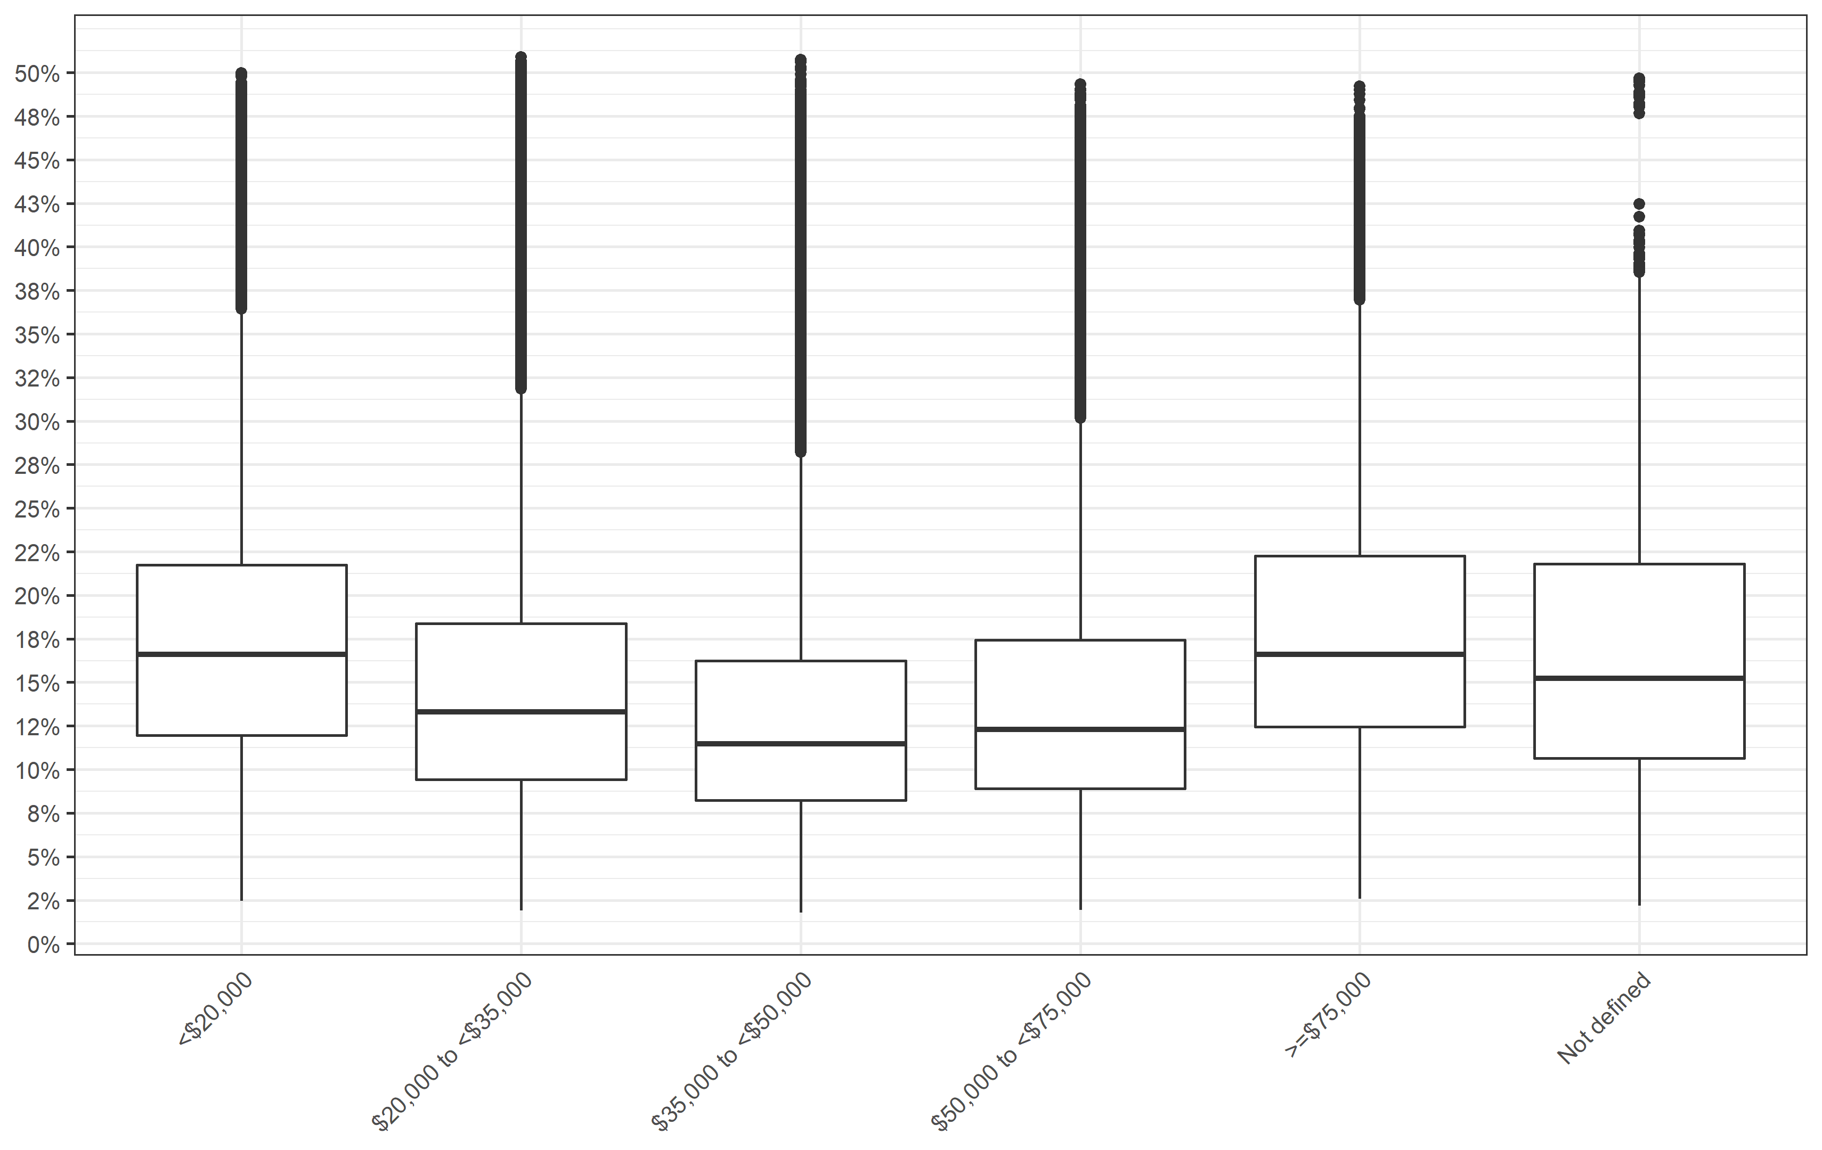

Figure S10: Attributable Fraction by living location stratified into median income group

